C# Sharp for a 2D array of size 3x3 and print the matrix.

Read a 2D array of size 3x3 and print the matrix :

------------------------------------------------------

Input elements in the matrix :

element - [0,0] : 1

element - [0,1] : 2

element - [0,2] : 3

element - [1,0] : 4

element - [1,1] : 5

element - [1,2] : 6

element - [2,0] : 7

element - [2,1] : 8

element - [2,2] : 9

The matrix is :

1 2 3

4 5 6

C# Sharp for addition of two Matrices of same size.

addition of two Matrices :

-----------------------------------------

Input the size of the square matrix (less than 5): 2

Input elements in the first matrix :

element - [0,0] : 2

element - [0,1] : 4

element - [1,0] : 6

element - [1,1] : 8

Input elements in the second matrix :

element - [0,0] : 1

element - [0,1] : 3

element - [1,0] : 5

element - [1,1] : 7

The First matrix is :

2 4

6 8

The Second matrix is :

1 3

5 7

The Addition of two matrix is :

3 7

11 15

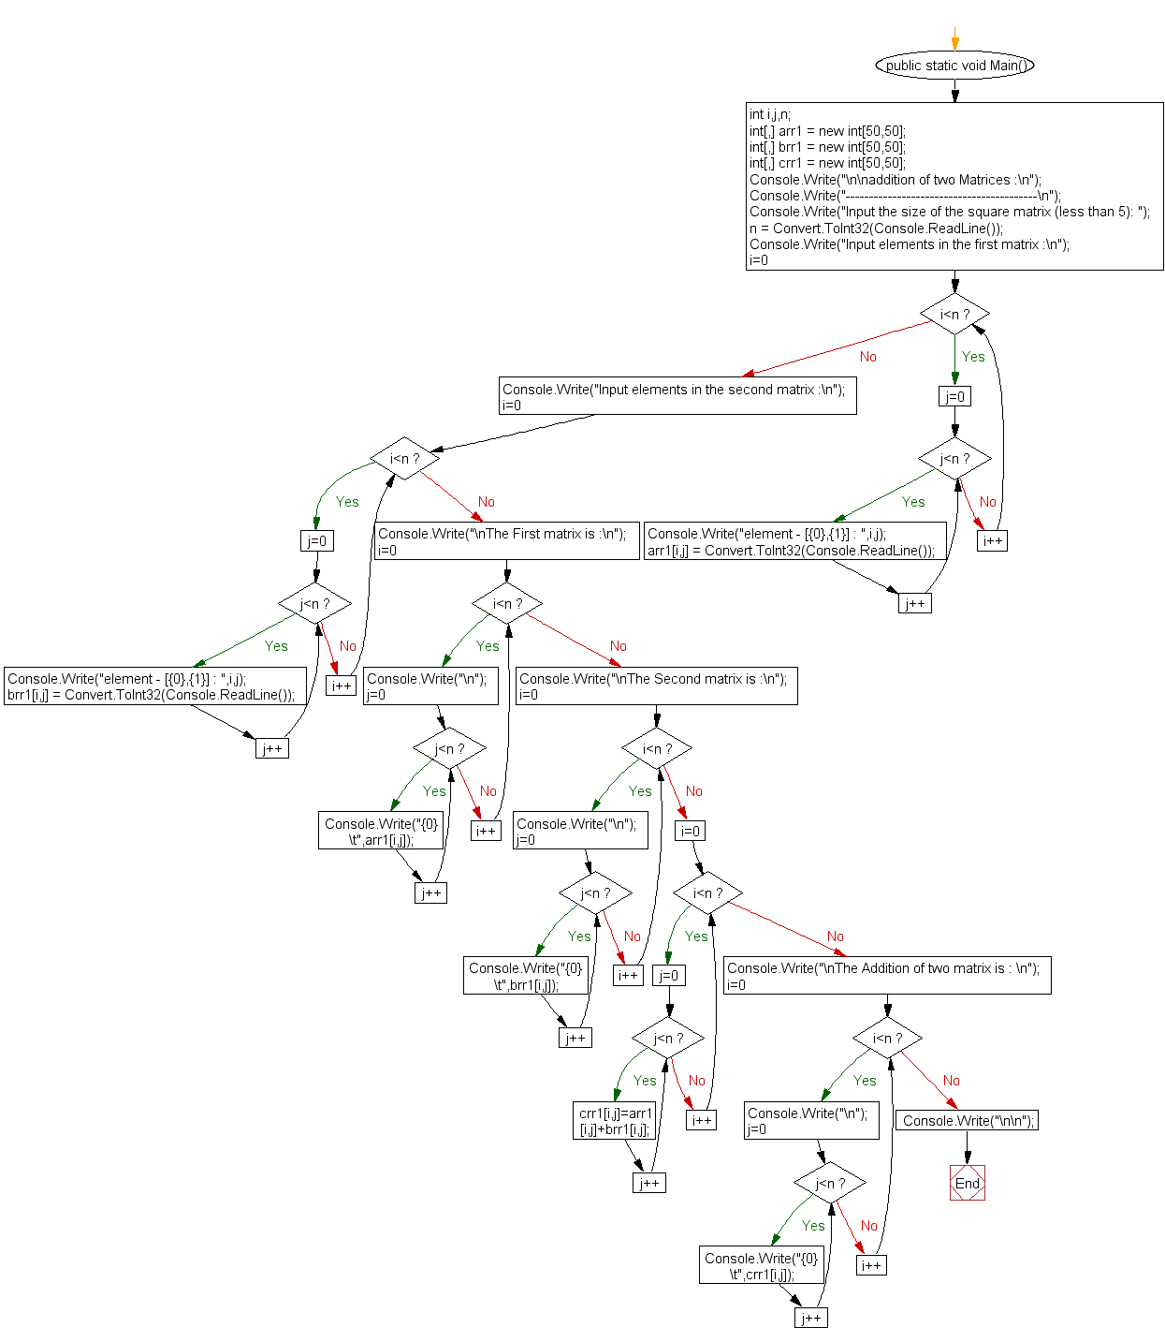

C# Sharp for subtraction of two Matrices.

Subtraction of two Matrices :

------------------------------

Input the size of the square matrix (less than 5): 2

Input elements in the first matrix :

element - [0,0] : 2

element - [0,1] : 4

element - [1,0] : 6

element - [1,1] : 8

Input elements in the second matrix :

element - [0,0] : 1

element - [0,1] : 3

element - [1,0] : 5

element - [1,1] : 7

The First matrix is :

2 4

6 8

The Second matrix is :

1 3

5 7

The Subtraction of two matrix is :

1 1

1 1

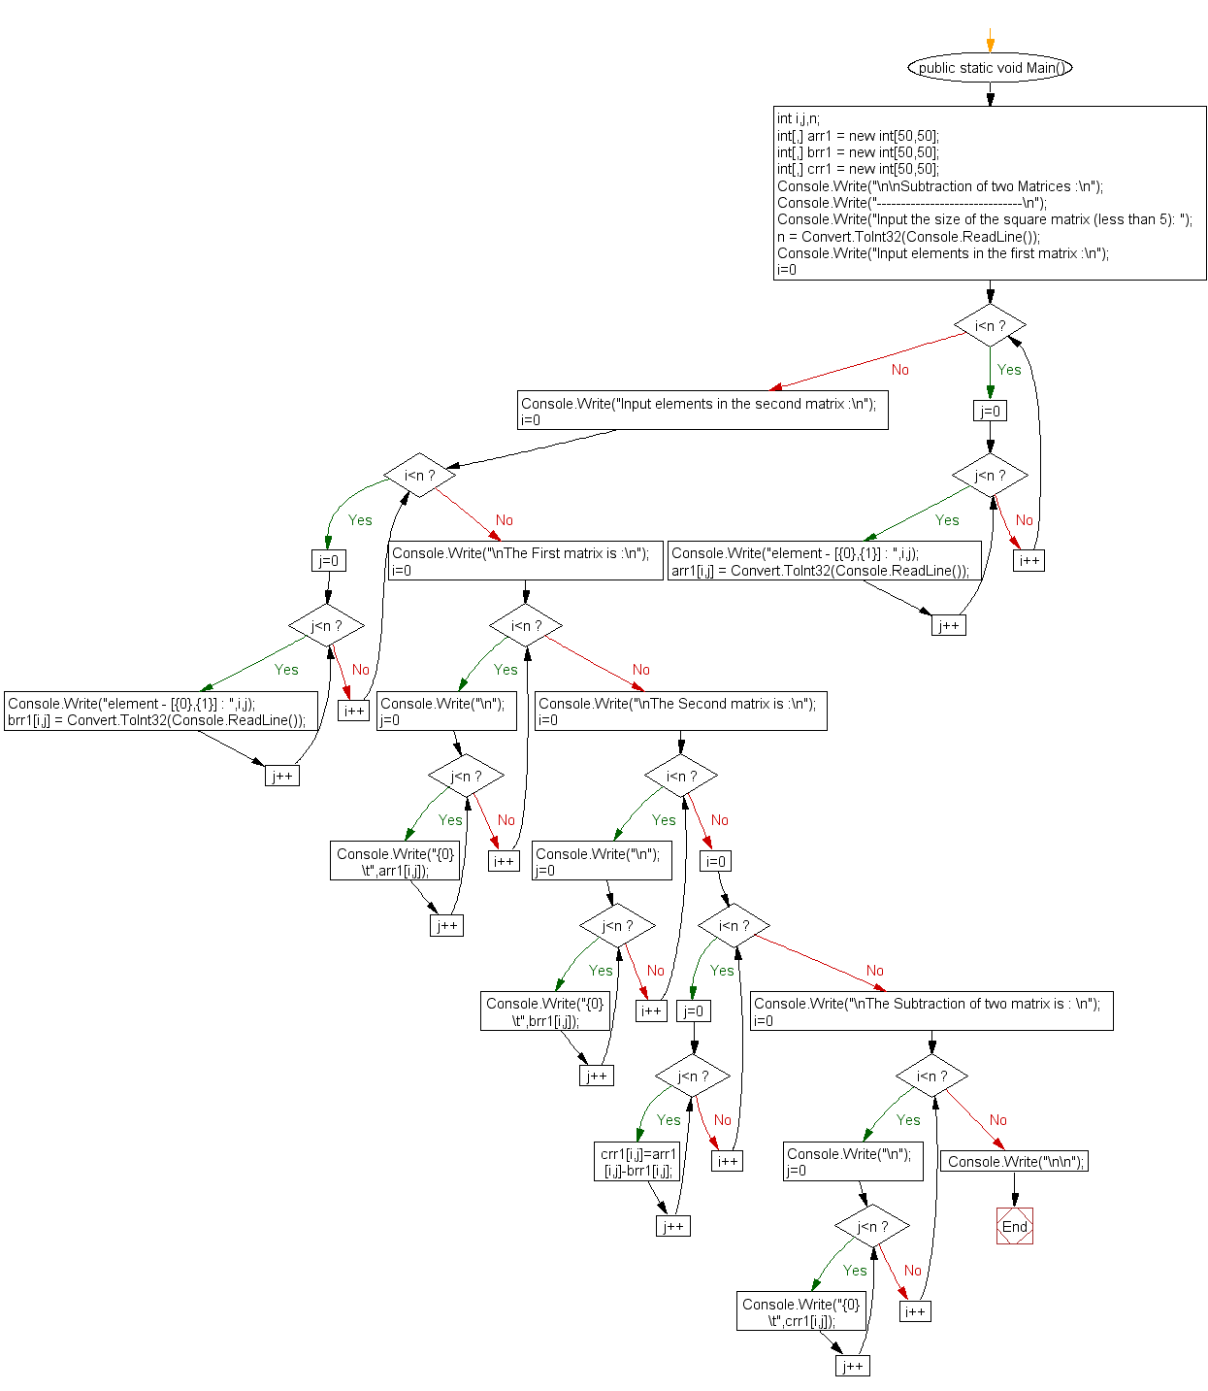

C# Sharp for multiplication of two square Matrices.

Multiplication of two Matrices

----------------------------------

Input the number of rows and columns of the first matrix :

Rows : 2

Columns : 2

Input the number of rows of the second matrix :

Rows : 2

Columns : 2

Input elements in the first matrix :

element - [0],[0] : 1

element - [0],[1] : 2

element - [1],[0] : 3

element - [1],[1] : 4

Input elements in the second matrix :

element - [0],[0] : 5

element - [0],[1] : 6

element - [1],[0] : 7

element - [1],[1] : 8

The First matrix is :

1 2

3 4

The Second matrix is :

5 6

7 8

The multiplication of two matrix is :

19 22

43 50

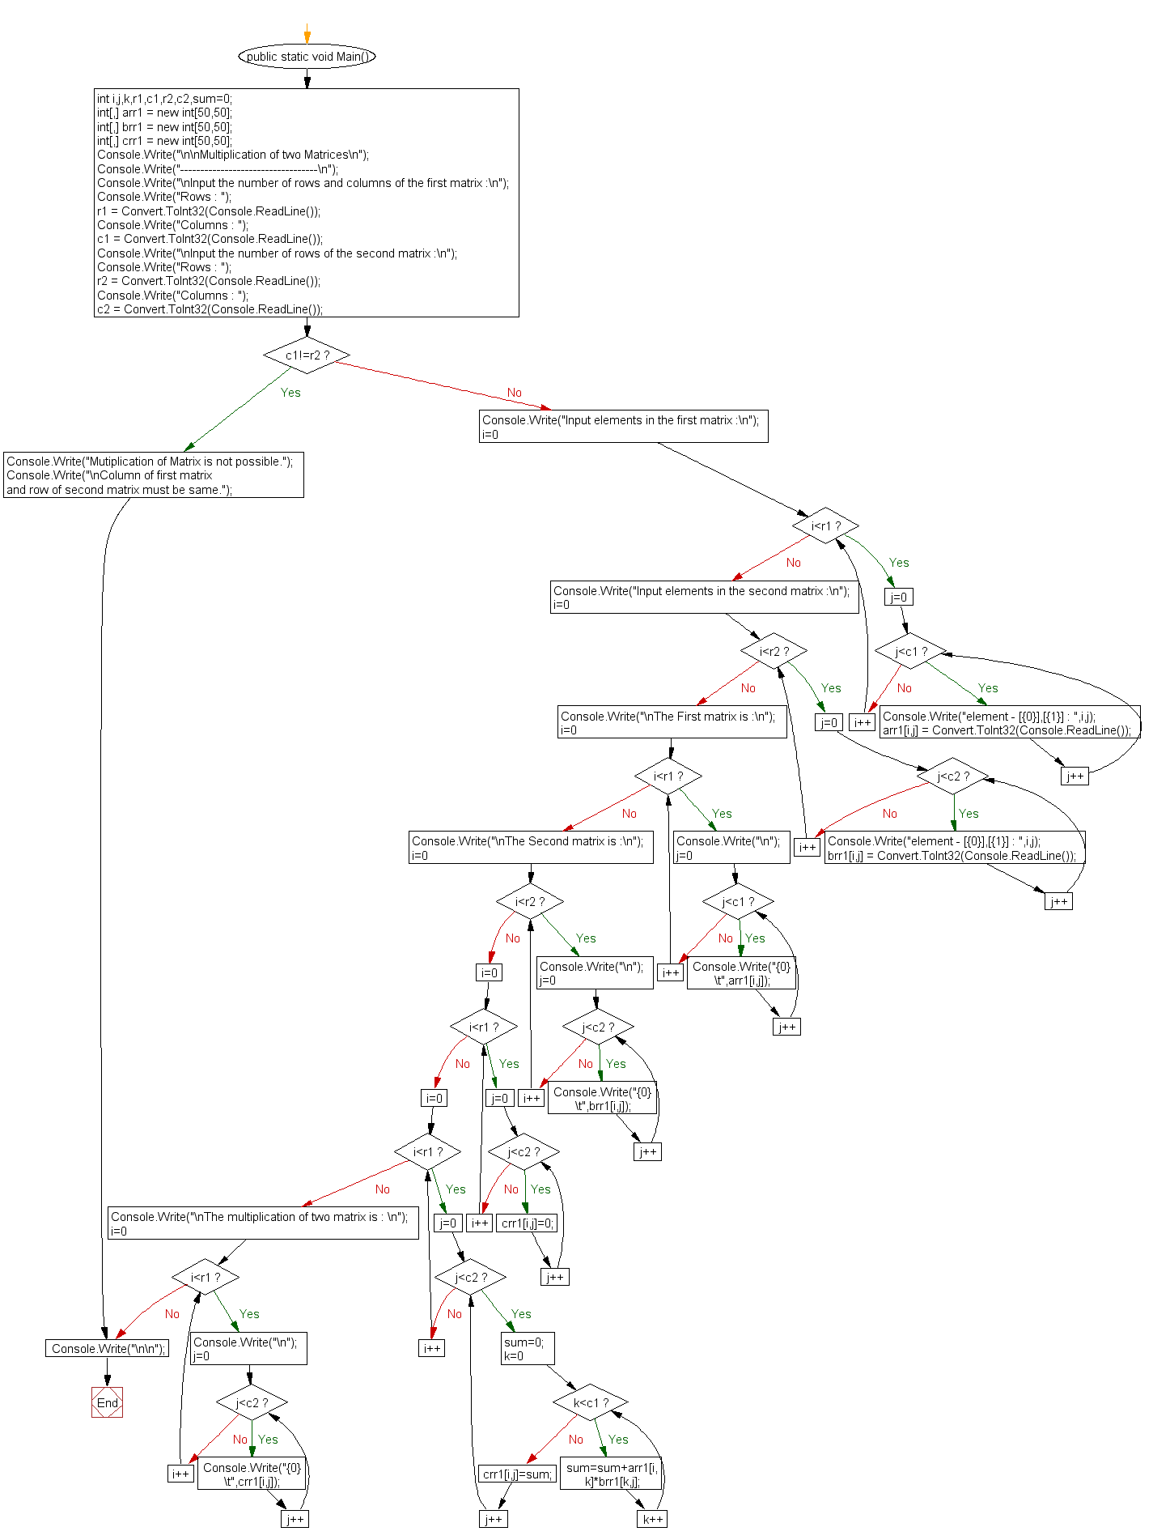

 C# Sharp to find transpose of a given matrix.

Transpose of a Matrix :

---------------------------

Input the number of rows and columns of the first matrix :

Rows : 2

Columns : 2

Input elements in the matrix :

element - [0],[0] : 1

element - [0],[1] : 2

element - [1],[0] : 3

element - [1],[1] : 4

The First matrix is :

1 2

3 4

The Transpose of a matrix is :

1 3

2 4

**Flowchart:**

